B. POSTER GUIDELINE
Format
  - The size of Poster is : 1280p (L) x 720p (H) (Landscape)
  - Poster saved as JPG / JPEG file extension with minimum size is 5 MB
  - Use PUBHEIC and ULM logo at top right corner at Poster (you can download the logo at https://...........
  - Please use proportional design for the poster
  - Poster be send at … (email) before November 5, 2021 at 23.59 (UTC +8)
The posters submitted should be prepared as electronic version (e-poster) with acceptable resolution and follows the dimension as below:

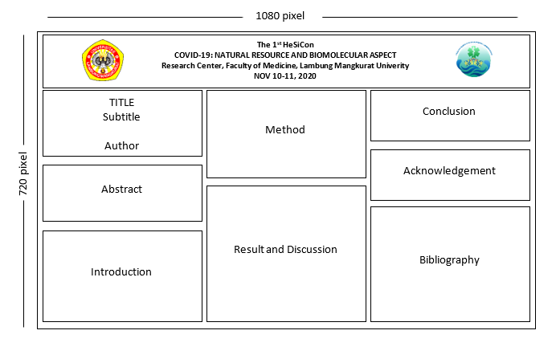
1ST PUBHEIC: PUBLIC HEALTH
INTERNATIONAL CONFERENCE OF UNIVERSITAS LAMBUNG MANGKURAT

“Public Health Response Amidst Prolonged Covid-19 Pandemic:
Lesson Learned From Lower-Middle Income Countries”

